**Ain Shams University**

**Faculty of Engineering**

**Computer and Systems Engineering Department**

**CSE412: Selected Topics in Computer Engineering**

**Content-Based Multimedia Retrieval System**

**Names: Codes:**

Mai Abdel Gawad Ahmed 1601503

Yara Ayman Yassien 1601669

Hadeer Essam Mohamed 1601646

Mohamed Sherif Awad 1601197

Alaa Mohamed Salah 1600280

Youmna Hassan Said 1601701

Amr Mostafa Abdel Halim 1600943

Marwan Mohamed Mohamed 1601345

# INTRODUCTION

In recent years, a rapid increase in the size of digital image databases has been observed. Everyday gigabytes of images are generated. Consequently, the search for the relevant information from image and video databases has become more challenging. To get accurate retrieval results is still an unsolved problem and an active research area. Content-based image retrieval (CBIR) is a process in which for a given query image, similar images are retrieved from a large image database based on their content similarity. A number of techniques have been suggested by researchers for content-based image retrieval. Also, for videos, Content-Based Video Retrieval (CBVR) system are used.

# TABLE OF CONTENTS

INTRODUCTION 2

TABLE OF CONTENTS 3

LIST OF FIGURES 4

DETAILED PROJECT DESCRIPTION 5

Content Based Image Retrieval 5

Content Based Video Retrieval 5

BENEFICIARIES OF THE PROJECT 6

DETAILED ANALYSIS 8

Part 1. Feature Extraction 8

Part 2. Indexing dataset 9

Part 3. Define Similarity metric 9

Part 4. Searching 9

DETAILED DESCRIPTION OF THE ADOPTED TECHNIQUES 10

For Image Retrieval 10

For Video Retrieval 11

TASK BREAKDOWN STRUCTURE 12

TIME PLAN 13

Team contribution 13

SYSTEM ARCHITECTURE 14

CBIR 14

CBVR 15

MULTIMEDIA DATABASE DESIGN 16

SYSTEM DESIGN 17

CBVR 17

TESTING SCENARIOS AND END USER GUIDE 18

CONCLUSION 24

REFERENCES 25

# LIST OF FIGURES

Figure 1:CBIR Architecture 13

Figure 2:CBVR Architecture 14

Figure 3:Home Screen 17

Figure 4:Image Retrieval Screen 17

Figure 5:Choosing Query Image 18

Figure 6:Choosing an Algorithm 18

Figure 7:Color Method 19

Figure 8:Shape Method 19

Figure 9:Histogram Method 20

Figure 10:Texture Method 20

Figure 11:Choosing Video 21

Figure 12:Open and Retrieve Video 22

Figure 13:CMD Commands 22

# DETAILED PROJECT DESCRIPTION

## Content Based Image Retrieval

"Content-based" means that the search examines the image's contents rather than the metadata associated with the image, such as keywords, tags, or descriptions.

In this context, "content" could refer to colors, shapes, textures, or any other information derived from the image itself.

CBIR is desirable because searches that rely solely on metadata are reliant on the quality and completeness of annotations.

Manually annotating images by entering keywords or metadata into a large database takes time and may not capture the keywords desired to describe the image.

In content-based image retrieval, the most common method for comparing two images (typically an example image and an image from the database) is to use an image distance measure. Image distance compares the similarity of two images in different dimensions such as histogram color layout and texture.

## Content Based Video Retrieval

Content Based Video Retrieval (CBVR) is becoming more popular to describe the

process of retrieving desired videos from a large collection based on features

extracted from the videos. The extracted features are used to index, classify,

and retrieve relevant and desired videos while filtering out unwanted ones.

Videos can be represented by the audio, text, faces, and objects in their frames.

Each video has its own motion features, color histograms, motion histograms,

text features, audio features, and features extracted from faces and objects in

its frames.

# BENEFICIARIES OF THE PROJECT

Content based multimedia retrieval system ca be used in many fields such as:

* Architectural and engineering design
* Art collections
* Crime prevention
* Geographical information and remote sensing systems
* Intellectual property
* Medical field:
* teaching: searching tools can be used to find important cases to present to students.
* Research: using services combining image content information with different kinds of data
* diagnostic procedure: image content descriptor-based queries can also be useful.
* Military applications
* Photograph archives
* Retail catalogs
* Digital Libraries: A digital library includes a module that is in charge of retrieving content-based images based on color, texture, and pattern.
* Mass media
* Forensic
* Fingerprint & DNA matching
* Surveillance Systems

# DETAILED ANALYSIS

CBIR approach pays greater attention to global and local information, such as color, shape, texture, region of an image.

## Part 1. Feature Extraction

Feature extraction is a means of extracting compact but semantically valuable information from images. This information is used as a signature for the image. Similar images should have similar signatures.

In this retrieval system, I implemented several image features descriptors:

* Histogram

To retrieve images, we compare between the histogram of the query image and find images from the database with similar histograms, those are the ones retrieved.

* Color based (HSV histogram)

To extract the color features from the content of an image, a proper color space (HSV in this case) and an effective color descriptor are determined through color histogram (Local color histogram).

* Texture-based (Gabor filter)

Texture can be thought of as repeated patterns of pixels over a spatial domain. Texture properties are the visual patterns in an image that have properties of homogeneity that do not result from the presence of only a single color or intensity. Frequency and orientation representations of the Gabor filter are similar to those of the human visual system. The images are filtered using the real parts of various Gabor filter kernels. The mean and variance of the filtered images are then used as features for classification, which is based on the least squared error.

* Shape-based (Histogram of Oriented Gradient (HOG))

In this descriptor, feature vector is extracted by segmenting image into smaller cells and for each cell, we accumulate a local histogram of gradient in several orientations over all the pixels in the cell.

## Part 2. Indexing dataset

Now apply image descriptor to each image in your dataset, extract features from these images, and write the features to storage (ex. CSV file), so that they can be later compared for similarity.

## Part 3. Define Similarity metric

Depending upon dataset and types of features extracted, define a method (ex. Euclidean distance, Cosine distance, and chi-squared distance) to compare features for similarity.

I used chi-squared distance for color histogram and HOG methods and least square error technique for gabor filter method to compare similarity between features.

## Part 4. Searching

This part performs actual search of user query image by (1) extracting features from this query image and then (2) apply your similarity function to compare the query features to the features already indexed. From there, system returns the most relevant results according to your similarity function.

# DETAILED DESCRIPTION OF THE ADOPTED TECHNIQUES

## For Image Retrieval

* Histogram
  + Color histogram represents the number of [pixels](https://en.wikipedia.org/wiki/Pixel) that have colors in each of a fixed list of color ranges, that span the image's [color space](https://en.wikipedia.org/wiki/Color_space), the set of all possible colors. Which are represented in values from 0 to 255, in our project to retrieve images we compare between the histogram of the query image and find images from the database with similar histograms, those are the ones retrieved
* Color-based
  + [HSV histogram](https://github.com/vamc-stash/image-retrieval/blob/master/src/color/color.py)  
    To extract the color features from the content of an image, a proper color space (HSV in this case) and an effective color descriptor are determined through color histogram (Local color histogram).
* Texture-based
  + [gabor filter](https://github.com/vamc-stash/image-retrieval/blob/master/src/gabor/gabor.py)  
    Texture can be thought of as repeated patterns of pixels over a spatial domain. Texture properties are the visual patterns in an image that have properties of homogeneity that do not result from the presence of only a single color or intensity. Frequency and orientation representations of the Gabor filter are similar to those of the human visual system. The images are filtered using the real parts of various Gabor filter kernels. The mean and variance of the filtered images are then used as features for classification, which is based on the least squared error.
* Shape-based
  + Histogram of oriented gradient (HOG)  
    In this descriptor, feature vector is extracted by segmenting image into smaller cells and for each cell, we accumulate a local histogram of gradient in several orientations over all the pixels in the cell.

## For Video Retrieval

We choose a straightforward approach for this: match videos by matching a sequence of frames.

To compare one video frame to another, we chose a simple algorithm that was easy to implement, easy to test, and somehow easy to optimize.

We use the root mean square error method for finding the average pixel difference across two RGB buffers of the same size and width.

Identical images will receive a score of 0.0, indicating an average difference of 0 across all pixels, completely dissimilar images (a black image and a white image) will receive a score of 255.0, indicating the maximum difference possible across R, G, and B for all pixels in the image.

# TASK BREAKDOWN STRUCTURE

# TIME PLAN



## Team contribution

* Image Retrieval

Mai Abdel Gawad Ahmed

Yara Ayman Yassien

Hadeer Essam Mohamed

Mohamed Sherif Awad

* Video Retrieval

Alaa Mohamed Salah

Youmna Hassan

* Desktop Application

Amr Mostafa

Marwan Mohamed

* Database Design

Amr Mostafa

* Documentation

Mai Abdel Gawad Ahmed

Yara Ayman Yassien

# SYSTEM ARCHITECTURE

## CBIR

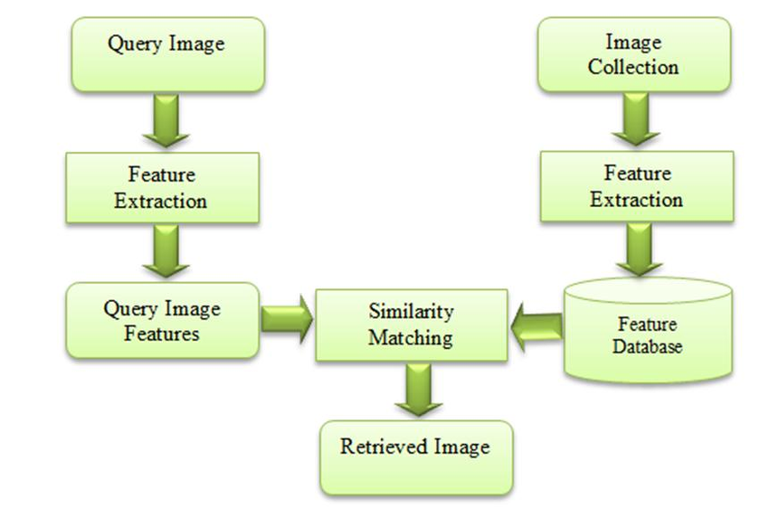

Figure 1:CBIR Architecture

## CBVR

Figure 2:CBVR Architecture

# MULTIMEDIA DATABASE DESIGN

|  |  |  |
| --- | --- | --- |
|  | **Multimedia** |  |
| **ID** | **directory** | **Type** |

**Videos**

|  |  |
| --- | --- |
| **Video ID** | video name |

**Images**

|  |  |
| --- | --- |
| **Image ID** | Image name |

**Color filter**

|  |  |
| --- | --- |
| **Image ID** | Value |

**Histogram filter**

|  |  |
| --- | --- |
| **Image ID** | Value |

**Shape filter**

|  |  |
| --- | --- |
| **Image ID** | value |

**Texture filter**

|  |  |
| --- | --- |
| **Image ID** | value |

# SYSTEM DESIGN

## CBVR

# TESTING SCENARIOS AND END USER GUIDE

In this partition, we will show all possible scenarios with the aid of user interface.

1. First the Home page is launched where we state whether we want to retrieve a video or an image or terminate the application

Figure :Home Screen

1. A picture containing background pattern

   Description automatically generatedIf we choose the Image option, we are represented with another screen where we can select the image we want and then retrieve the images similar to it by 4 different methods

Figure :Image Retrieval Screen

1. After choosing open image we can then choose any image we want so we can apply retrieval methods on it

Figure :Choosing Query Image

1. After choosing the image it is presented on the UI and we are ready to choose from the four algorithms

Figure :Choosing an Algorithm

1. Here is an example after applying the retrieval by color method we get all the images that match the features of the chosen image

Figure :Color Method

1. using shape:

Figure :Shape Method

1. Graphical user interface

   Description automatically generated Using Histogram:

Figure :Histogram Method

1. Using Texture:

Figure :Texture Method

1. After choosing video option we are represented with the video screen where we can choose the video we want

Figure :Choosing Video

1. after pressing open and retrieve Video then this video is being played and we the retrieved videos paths are displayed in the command window

Figure :Open and Retrieve Video

Figure :CMD Commands

# CONCLUSION

As the amount of multimedia data is growing every day on the internet, and the computational power and time consuming on searching and filtering those data is becoming more important and critical new features and techniques must be developed and updated like CBIR and CBVR techniques and features so that the accuracy of retrieval increase and indexing becomes easier with the growing amount of data.

# REFERENCES

Tyagi V. (2017) Content-Based Image Retrieval: An Introduction. In: Content-Based Image Retrieval. Springer, Singapore. <https://doi.org/10.1007/978-981-10-6759-4_1>

Tyagi V. (2017) Content-Based Image Retrieval Using Integrated Color, Texture, and Shape Features. In: Content-Based Image Retrieval. Springer, Singapore. <https://doi.org/10.1007/978-981-10-6759-4_13>